EXPERIMENT 1a
SETTING UP PYTHON ENVIRONMENT AND LIBRARIES – JUPYTER NOTEBOOK
Aim
To install Python, configure Jupyter Notebook, understand the notebook environment, execute Python programs, create Markdown cells, and use basic Jupyter Notebook features for Data Analytics applications.
Algorithm
Algorithm 1: Installing Python
Step 1:
Download Python from python.org.
Step 2:
Run the Python installer.
Step 3:
Select "Add Python to PATH".
Step 4:
Click "Install Now".
Step 5:
Verify the installation using:
python --version
Step 6:
Observe the installed Python version.
Algorithm 2: Installing Jupyter Notebook
Step 1:
Open Command Prompt.
Step 2:
Install Jupyter Notebook using:
pip install notebook
Step 3:
Launch Jupyter Notebook using:
jupyter notebook
Step 4:
The browser automatically opens the Jupyter Notebook Dashboard.
Algorithm 3: Creating a Notebook
Step 1:
Open the Jupyter Notebook Dashboard.
Step 2:
Select New → Python 3.
Step 3:
Create a new notebook.
Step 4:
Rename the notebook.
Step 5:
Create Code cells and Markdown cells.
Step 6:
Execute each cell using Shift + Enter.
Program 1: Simple Python Program
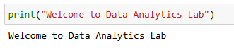
Program 2: Arithmetic Operations
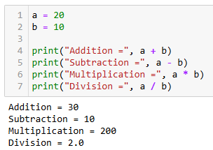
Program 3: Display Student Details
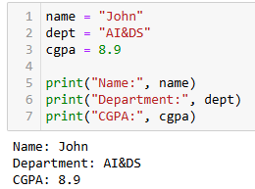
Program 4: Using NumPy Library
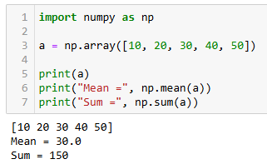
Program 5: Using Pandas Library
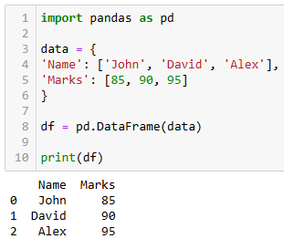

Program 6: Data Visualization
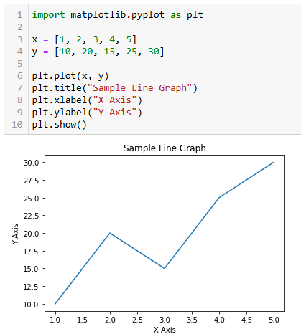

Result
Thus, Python was successfully installed and configured with Jupyter Notebook. Basic Python programs were executed, Markdown cells were created, and libraries such as NumPy, Pandas, and Matplotlib were used successfully for Data Analytics applications.

